# Questions guide to build an EMP

You can build your marketing plan for exports by answering these questions.

Then you can transform questions into titles, and the plan is ready

## Β. Market analysis

What is the average price for your type of product/service in the target market? How does it compare to your costs? Do you think you can afford such a price, taking into consideration also all exporting costs, such as logistics, certifications, etc.)?

Is there sufficient demand in the selected target market for your product/service? Is this demand already (even partially) being met by local firms? Do you think customers are fully satisfied by the present offer or that they could do with something new, better targeted to their needs and /or curiosity?

Whom would you sell to? Directly to consumers? To importers? To modern distribution buyers? Can you make a list of importers / dealers who could be your target?

What are the economic trends of the country? How stable is the economic situation? What are the main drivers of their economic growth?

How is the exchange rate between the euro and dollar going? Is there a recent past of exchange rate volatility?

What are the demographic trends?

Where are your customers? All in large cities or scattered across the country? This can affect market channels, logistics and product management (especially in the case of fresh (or frozen) products, which need a cold chain to be activated and not to be broken.

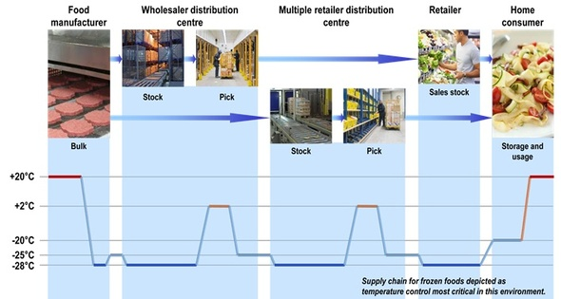

How is the regulatory mainframe? What about Tariff and non-tariff barriers? Import quotas? What about quarantine, labeling standards, standards and consumer protection rules, duties, taxes? Are there commercial agreements between your country and the target country?

**Competitive analysis**

Who are your local competitors? How big are they? What services do they offer? Are they active in different sectors? Are they vertically integrated (that is, do they work also in previous or subsequent phases of the supply chain? And what about other exporters who are already present on the market? Where are they from? Do they benefit from a competitive advantages when compared with you? Why? What could your competitive advantage be? These elements are very important, also because competitors could react to your entry (e.g. by means of promotional tools), if it is regarded as a relevant threat.

Concentration of supply is a very useful indicator: it measures the % of product offered on the target market by the first 5, 10, 20 operators. It tells you if you are going to compete with a few, big companies (which can be tricky) or with a large number of small businesses (which is easier, even if small firms can have a very good local reputation which, at least partially, protects them from competition).

*Please make a list of your main competitors:*

|  |  |  |
| --- | --- | --- |
| Company name | Local producer/exporter | Products |
|  |  |  |
|  |  |  |
|  |  |  |

**Planning of distribution, logistics and payments**

Distribution channels: which channels are more relevant and more suitable, as interlocutors, for you?

How will you approach them? Will you send company representatives, will you contact them directly?

Have you identified a shipping agent to transport your products?

How are you going to organise logistics (transportation but also storage), shipping documents, etc? Which service providers (names) will you rely on?

*And particularly:*

* *Who will pay for the freight charges?*
* *What type of storage facility will you activate in the target country?*
* *What kind of containers will be used for shipping?*
* *How much does the shipping cost?*
* *At what point will the importer take full responsibility for the products?*
* *If the products are damaged whilst shipping who will take responsibility?*

How are you going to settle payment agreements?

How are you going to protect yourself against payment risk?

How are you going to protect yourself against exchange rates risk?

What will the features of your commercial contract be?